Web Engineering

Lab # 03

*Objectives*

* 1. Designing the table and form in HTML
  2. Task1 Design the table with following details.

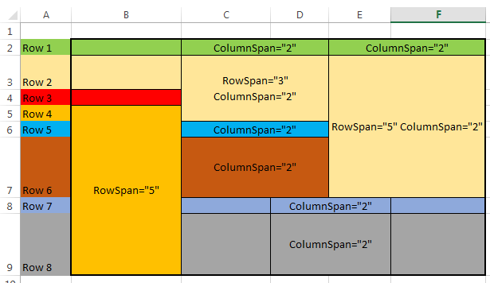

Note: <td bgcolor="red">January</td>

Task 2

**Create a Table as giving Structure**

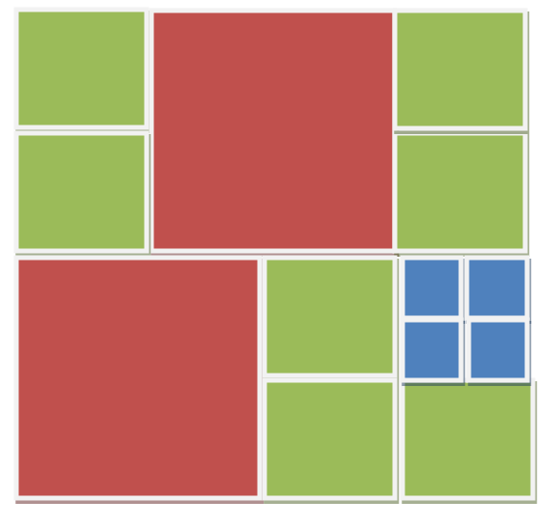

**Task 3**

**Write code for displaying for following form**



**Task 4**

**Write code for displaying for following form**

